1 run......

Downloading: 100%

464/464 [00:00<00:00, 8.27kB/s]

Downloading: 100%

270M/270M [00:12<00:00, 23.3MB/s]

training 1 epoch...

40.30813217163086 seconds used......

1 training finished! average train loss: 0.8490230292878687

evaluating...

Confusion matrix, without normalization

[[ 269 143 361]

[ 61 195 174]

[ 116 145 2068]]

Normalized confusion matrix

[[0.34799483 0.18499353 0.46701164]

[0.14186047 0.45348837 0.40465116]

[0.04980678 0.06225848 0.88793474]]

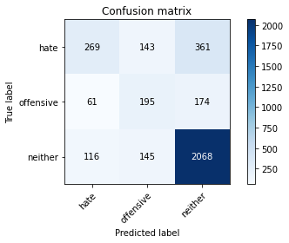

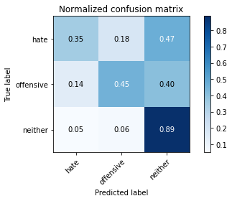

precision recall f1-score support

hate 0.60 0.35 0.44 773

offensive 0.40 0.45 0.43 430

neither 0.79 0.89 0.84 2329

accuracy 0.72 3532

macro avg 0.60 0.56 0.57 3532

weighted avg 0.71 0.72 0.70 3532

average eval_loss: 0.6988083806078312, accuracy: 0.7168742921857305

training 2 epoch...

39.3022894859314 seconds used......

2 training finished! average train loss: 0.58933604815427

evaluating...

Confusion matrix, without normalization

[[ 394 113 266]

[ 88 202 140]

[ 202 188 1939]]

Normalized confusion matrix

[[0.50970246 0.1461837 0.34411384]

[0.20465116 0.46976744 0.3255814 ]

[0.0867325 0.08072134 0.83254616]]

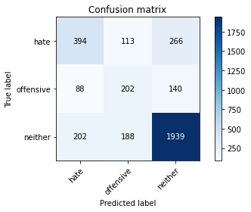

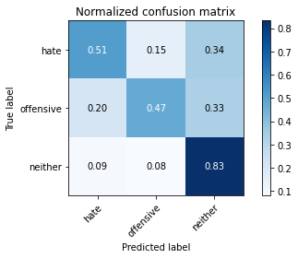

precision recall f1-score support

hate 0.58 0.51 0.54 773

offensive 0.40 0.47 0.43 430

neither 0.83 0.83 0.83 2329

accuracy 0.72 3532

macro avg 0.60 0.60 0.60 3532

weighted avg 0.72 0.72 0.72 3532

average eval_loss: 0.6997555389916156, accuracy: 0.7177236693091733

training 3 epoch...

39.40070295333862 seconds used......

3 training finished! average train loss: 0.36258684959322374

evaluating...

Confusion matrix, without normalization

[[ 450 50 273]

[ 144 130 156]

[ 254 96 1979]]

Normalized confusion matrix

[[0.58214748 0.06468305 0.35316947]

[0.33488372 0.30232558 0.3627907 ]

[0.10905968 0.04121941 0.84972091]]

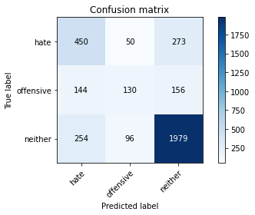

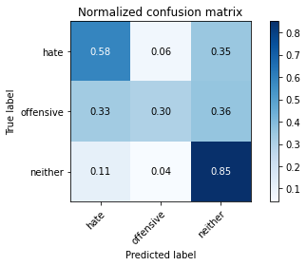

precision recall f1-score support

hate 0.53 0.58 0.56 773

offensive 0.47 0.30 0.37 430

neither 0.82 0.85 0.84 2329

accuracy 0.72 3532

macro avg 0.61 0.58 0.59 3532

weighted avg 0.72 0.72 0.72 3532

average eval_loss: 0.7458815886139196, accuracy: 0.7245186862967158

training 4 epoch...

39.35638165473938 seconds used......

4 training finished! average train loss: 0.1725646510003085

evaluating...

Confusion matrix, without normalization

[[ 511 65 197]

[ 153 173 104]

[ 394 169 1766]]

Normalized confusion matrix

[[0.6610608 0.08408797 0.25485123]

[0.35581395 0.40232558 0.24186047]

[0.16917132 0.07256333 0.75826535]]

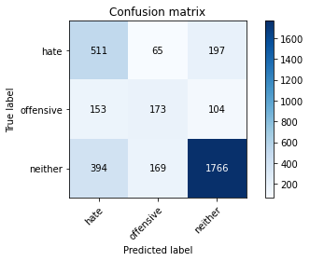

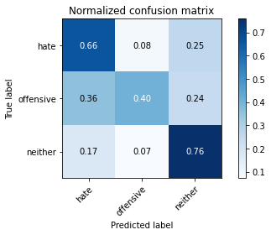

precision recall f1-score support

hate 0.48 0.66 0.56 773

offensive 0.43 0.40 0.41 430

neither 0.85 0.76 0.80 2329

accuracy 0.69 3532

macro avg 0.59 0.61 0.59 3532

weighted avg 0.72 0.69 0.70 3532

average eval_loss: 1.036565990939652, accuracy: 0.6936579841449604

training 5 epoch...

39.29622483253479 seconds used......

5 training finished! average train loss: 0.07461958713480894

evaluating...

Confusion matrix, without normalization

[[ 375 101 297]

[ 96 186 148]

[ 191 140 1998]]

Normalized confusion matrix

[[0.4851229 0.13065977 0.38421734]

[0.22325581 0.43255814 0.34418605]

[0.08200945 0.06011164 0.85787892]]

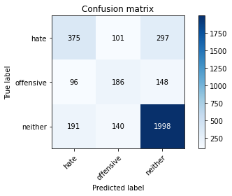

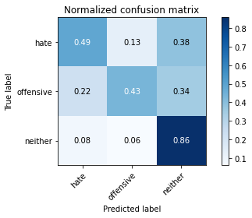

precision recall f1-score support

hate 0.57 0.49 0.52 773

offensive 0.44 0.43 0.43 430

neither 0.82 0.86 0.84 2329

accuracy 0.72 3532

macro avg 0.61 0.59 0.60 3532

weighted avg 0.72 0.72 0.72 3532

average eval_loss: 1.0889717850223772, accuracy: 0.7245186862967158

training 6 epoch...

39.326868772506714 seconds used......

6 training finished! average train loss: 0.028199464685338384

evaluating...

Confusion matrix, without normalization

[[ 376 150 247]

[ 84 223 123]

[ 219 236 1874]]

Normalized confusion matrix

[[0.48641656 0.19404916 0.31953428]

[0.19534884 0.51860465 0.28604651]

[0.09403177 0.10133104 0.80463718]]

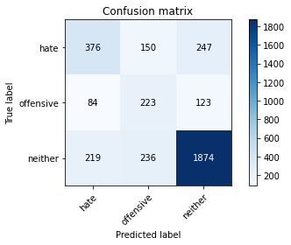

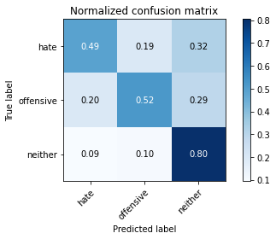

precision recall f1-score support

hate 0.55 0.49 0.52 773

offensive 0.37 0.52 0.43 430

neither 0.84 0.80 0.82 2329

accuracy 0.70 3532

macro avg 0.59 0.60 0.59 3532

weighted avg 0.72 0.70 0.71 3532

average eval_loss: 1.2893214008565677, accuracy: 0.7001698754246886

training 7 epoch...

39.42633318901062 seconds used......

7 training finished! average train loss: 0.014204152876556039

evaluating...

Confusion matrix, without normalization

[[ 320 108 345]

[ 74 182 174]

[ 145 115 2069]]

Normalized confusion matrix

[[0.41397154 0.13971539 0.44631307]

[0.17209302 0.42325581 0.40465116]

[0.06225848 0.04937742 0.8883641 ]]

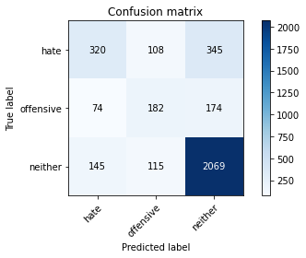

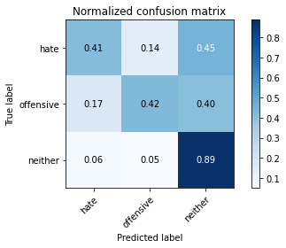

precision recall f1-score support

hate 0.59 0.41 0.49 773

offensive 0.45 0.42 0.44 430

neither 0.80 0.89 0.84 2329

accuracy 0.73 3532

macro avg 0.61 0.58 0.59 3532

weighted avg 0.71 0.73 0.71 3532

average eval_loss: 1.4456826068755597, accuracy: 0.727916194790487

training 8 epoch...

39.334325313568115 seconds used......

8 training finished! average train loss: 0.0065311193425721305

evaluating...

Confusion matrix, without normalization

[[ 399 103 271]

[ 96 198 136]

[ 215 173 1941]]

Normalized confusion matrix

[[0.51617076 0.13324709 0.35058215]

[0.22325581 0.46046512 0.31627907]

[0.0923143 0.07428081 0.83340489]]

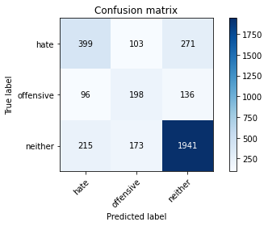

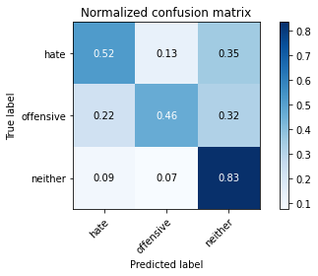

precision recall f1-score support

hate 0.56 0.52 0.54 773

offensive 0.42 0.46 0.44 430

neither 0.83 0.83 0.83 2329

accuracy 0.72 3532

macro avg 0.60 0.60 0.60 3532

weighted avg 0.72 0.72 0.72 3532

average eval_loss: 1.5435242123775563, accuracy: 0.7185730464326161

training 9 epoch...

39.39520621299744 seconds used......

9 training finished! average train loss: 0.00821442495039191

evaluating...

Confusion matrix, without normalization

[[ 430 93 250]

[ 111 183 136]

[ 273 141 1915]]

Normalized confusion matrix

[[0.55627426 0.12031048 0.32341527]

[0.25813953 0.4255814 0.31627907]

[0.11721769 0.060541 0.82224131]]

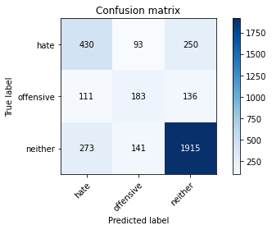

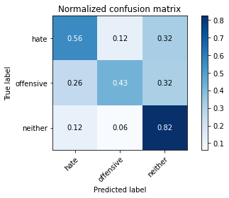

precision recall f1-score support

hate 0.53 0.56 0.54 773

offensive 0.44 0.43 0.43 430

neither 0.83 0.82 0.83 2329

accuracy 0.72 3532

macro avg 0.60 0.60 0.60 3532

weighted avg 0.72 0.72 0.72 3532

average eval_loss: 1.5543285090539416, accuracy: 0.7157417893544734

training 10 epoch...

39.37315225601196 seconds used......

10 training finished! average train loss: 0.018773914425307636

evaluating...

Confusion matrix, without normalization

[[ 351 127 295]

[ 60 206 164]

[ 178 174 1977]]

Normalized confusion matrix

[[0.45407503 0.16429495 0.38163001]

[0.13953488 0.47906977 0.38139535]

[0.07642765 0.07471018 0.84886217]]

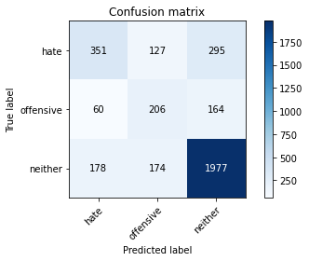

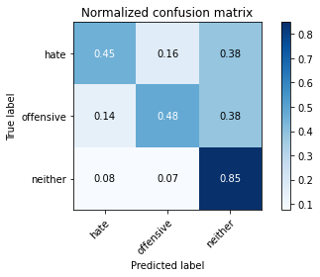

precision recall f1-score support

hate 0.60 0.45 0.52 773

offensive 0.41 0.48 0.44 430

neither 0.81 0.85 0.83 2329

accuracy 0.72 3532

macro avg 0.60 0.59 0.59 3532

weighted avg 0.72 0.72 0.71 3532

average eval_loss: 1.5031265687134305, accuracy: 0.717440543601359

2 run......

training 1 epoch...

39.34355711936951 seconds used......

1 training finished! average train loss: 0.8397105656524393

evaluating...

Confusion matrix, without normalization

[[ 281 103 389]

[ 74 157 199]

[ 137 97 2095]]

Normalized confusion matrix

[[0.36351876 0.13324709 0.50323415]

[0.17209302 0.36511628 0.4627907 ]

[0.05882353 0.04164878 0.89952769]]

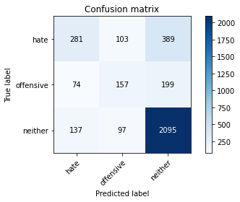

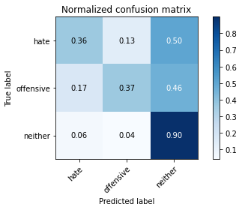

precision recall f1-score support

hate 0.57 0.36 0.44 773

offensive 0.44 0.37 0.40 430

neither 0.78 0.90 0.84 2329

accuracy 0.72 3532

macro avg 0.60 0.54 0.56 3532

weighted avg 0.69 0.72 0.70 3532

average eval_loss: 0.6805330634453876, accuracy: 0.7171574178935447

training 2 epoch...

39.26070189476013 seconds used......

2 training finished! average train loss: 0.5830202837360097

evaluating...

Confusion matrix, without normalization

[[ 280 86 407]

[ 53 147 230]

[ 82 75 2172]]

Normalized confusion matrix

[[0.3622251 0.11125485 0.52652005]

[0.12325581 0.34186047 0.53488372]

[0.03520824 0.03220266 0.93258909]]

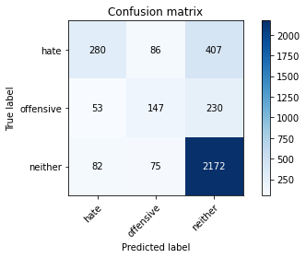

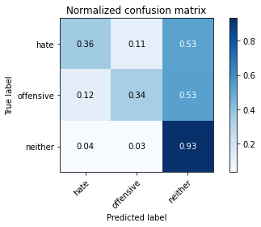

precision recall f1-score support

hate 0.67 0.36 0.47 773

offensive 0.48 0.34 0.40 430

neither 0.77 0.93 0.85 2329

accuracy 0.74 3532

macro avg 0.64 0.55 0.57 3532

weighted avg 0.72 0.74 0.71 3532

average eval_loss: 0.6880597820726492, accuracy: 0.7358437146092865

training 3 epoch...

39.29193043708801 seconds used......

3 training finished! average train loss: 0.37370107119733637

evaluating...

Confusion matrix, without normalization

[[ 302 65 406]

[ 74 133 223]

[ 90 63 2176]]

Normalized confusion matrix

[[0.39068564 0.08408797 0.52522639]

[0.17209302 0.30930233 0.51860465]

[0.03864319 0.02705024 0.93430657]]

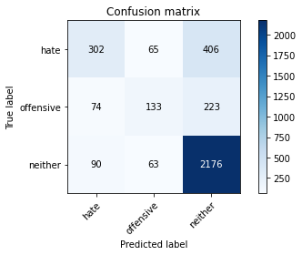

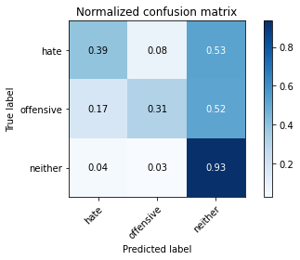

precision recall f1-score support

hate 0.65 0.39 0.49 773

offensive 0.51 0.31 0.38 430

neither 0.78 0.93 0.85 2329

accuracy 0.74 3532

macro avg 0.64 0.54 0.57 3532

weighted avg 0.72 0.74 0.71 3532

average eval_loss: 0.7801657644873958, accuracy: 0.7392412231030577

training 4 epoch...

39.262187480926514 seconds used......

4 training finished! average train loss: 0.16858129362690258

evaluating...

Confusion matrix, without normalization

[[ 226 122 425]

[ 35 186 209]

[ 61 106 2162]]

Normalized confusion matrix

[[0.2923674 0.15782665 0.54980595]

[0.08139535 0.43255814 0.48604651]

[0.0261915 0.0455131 0.92829541]]

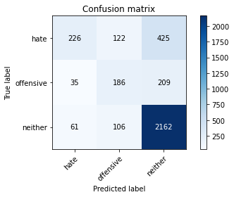

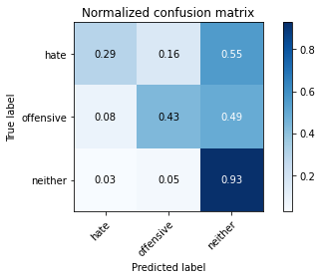

precision recall f1-score support

hate 0.70 0.29 0.41 773

offensive 0.45 0.43 0.44 430

neither 0.77 0.93 0.84 2329

accuracy 0.73 3532

macro avg 0.64 0.55 0.57 3532

weighted avg 0.72 0.73 0.70 3532

average eval_loss: 1.0581955186980592, accuracy: 0.7287655719139298

training 5 epoch...

39.28401970863342 seconds used......

5 training finished! average train loss: 0.06331897323532777

evaluating...

Confusion matrix, without normalization

[[ 325 118 330]

[ 75 194 161]

[ 142 136 2051]]

Normalized confusion matrix

[[0.42043984 0.15265201 0.42690815]

[0.1744186 0.45116279 0.3744186 ]

[0.06097037 0.05839416 0.88063547]]

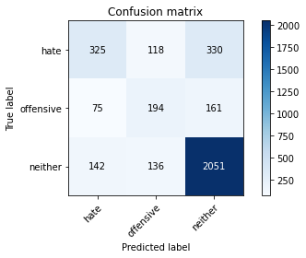

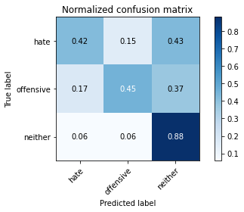

precision recall f1-score support

hate 0.60 0.42 0.49 773

offensive 0.43 0.45 0.44 430

neither 0.81 0.88 0.84 2329

accuracy 0.73 3532

macro avg 0.61 0.58 0.59 3532

weighted avg 0.72 0.73 0.72 3532

average eval_loss: 1.1874609913698024, accuracy: 0.7276330690826727

training 6 epoch...

39.31552457809448 seconds used......

6 training finished! average train loss: 0.0299254852318439

evaluating...

Confusion matrix, without normalization

[[ 299 136 338]

[ 66 201 163]

[ 128 152 2049]]

Normalized confusion matrix

[[0.38680466 0.1759379 0.43725744]

[0.15348837 0.46744186 0.37906977]

[0.05495921 0.06526406 0.87977673]]

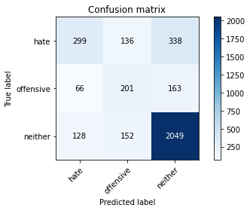

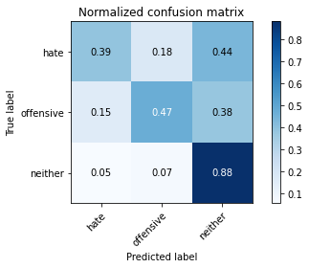

precision recall f1-score support

hate 0.61 0.39 0.47 773

offensive 0.41 0.47 0.44 430

neither 0.80 0.88 0.84 2329

accuracy 0.72 3532

macro avg 0.61 0.58 0.58 3532

weighted avg 0.71 0.72 0.71 3532

average eval_loss: 1.305277375262336, accuracy: 0.7216874292185731

training 7 epoch...

39.310462951660156 seconds used......

7 training finished! average train loss: 0.026139289564029736

evaluating...

Confusion matrix, without normalization

[[ 392 74 307]

[ 106 169 155]

[ 195 117 2017]]

Normalized confusion matrix

[[0.50711514 0.09573092 0.39715395]

[0.24651163 0.39302326 0.36046512]

[0.08372692 0.05023615 0.86603693]]

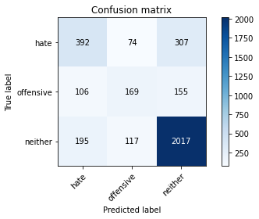

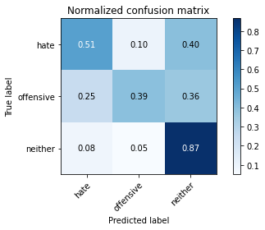

precision recall f1-score support

hate 0.57 0.51 0.53 773

offensive 0.47 0.39 0.43 430

neither 0.81 0.87 0.84 2329

accuracy 0.73 3532

macro avg 0.62 0.59 0.60 3532

weighted avg 0.72 0.73 0.72 3532

average eval_loss: 1.323723191721628, accuracy: 0.7298980747451869

training 8 epoch...

39.297192096710205 seconds used......

8 training finished! average train loss: 0.018584426408098202

evaluating...

Confusion matrix, without normalization

[[ 326 91 356]

[ 78 180 172]

[ 125 112 2092]]

Normalized confusion matrix

[[0.42173351 0.11772316 0.46054334]

[0.18139535 0.41860465 0.4 ]

[0.0536711 0.04808931 0.89823959]]

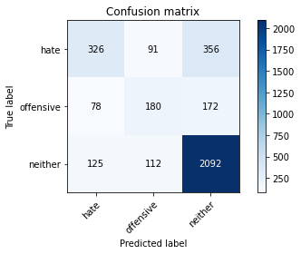

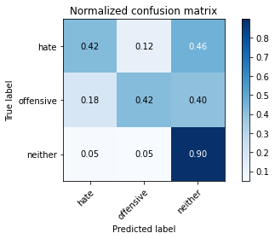

precision recall f1-score support

hate 0.62 0.42 0.50 773

offensive 0.47 0.42 0.44 430

neither 0.80 0.90 0.85 2329

accuracy 0.74 3532

macro avg 0.63 0.58 0.60 3532

weighted avg 0.72 0.74 0.72 3532

average eval_loss: 1.4617940700681364, accuracy: 0.7355605889014722

training 9 epoch...

39.35008788108826 seconds used......

9 training finished! average train loss: 0.014181892960852156

evaluating...

Confusion matrix, without normalization

[[ 322 97 354]

[ 83 181 166]

[ 140 107 2082]]

Normalized confusion matrix

[[0.41655886 0.12548512 0.45795602]

[0.19302326 0.42093023 0.38604651]

[0.06011164 0.04594246 0.8939459 ]]

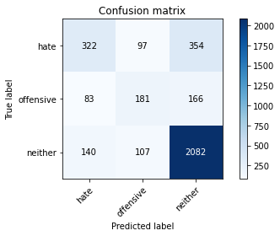

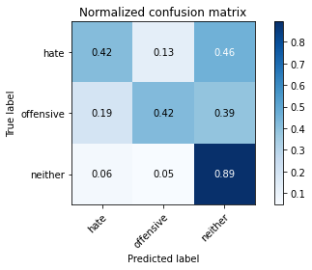

precision recall f1-score support

hate 0.59 0.42 0.49 773

offensive 0.47 0.42 0.44 430

neither 0.80 0.89 0.84 2329

accuracy 0.73 3532

macro avg 0.62 0.58 0.59 3532

weighted avg 0.71 0.73 0.72 3532

average eval_loss: 1.552802803615729, accuracy: 0.7318799546998868

training 10 epoch...

39.286150217056274 seconds used......

10 training finished! average train loss: 0.008540070787530373

evaluating...

Confusion matrix, without normalization

[[ 292 137 344]

[ 60 219 151]

[ 114 159 2056]]

Normalized confusion matrix

[[0.37774903 0.17723157 0.4450194 ]

[0.13953488 0.50930233 0.35116279]

[0.04894805 0.06826964 0.88278231]]

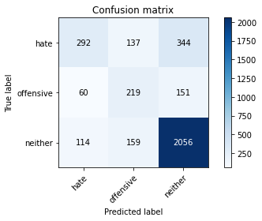

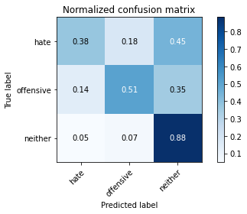

precision recall f1-score support

hate 0.63 0.38 0.47 773

offensive 0.43 0.51 0.46 430

neither 0.81 0.88 0.84 2329

accuracy 0.73 3532

macro avg 0.62 0.59 0.59 3532

weighted avg 0.72 0.73 0.72 3532

average eval_loss: 1.5986286445631315, accuracy: 0.7267836919592299

3 run......

training 1 epoch...

39.37087535858154 seconds used......

1 training finished! average train loss: 0.8266711775313087

evaluating...

Confusion matrix, without normalization

[[ 336 59 378]

[ 94 128 208]

[ 158 76 2095]]

Normalized confusion matrix

[[0.43467012 0.076326 0.48900388]

[0.21860465 0.29767442 0.48372093]

[0.06784027 0.03263203 0.89952769]]

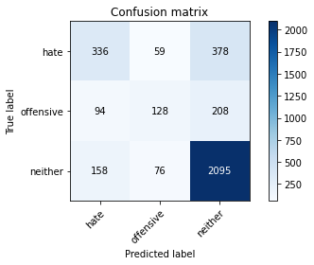

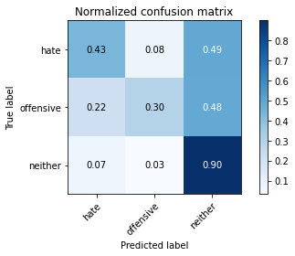

precision recall f1-score support

hate 0.57 0.43 0.49 773

offensive 0.49 0.30 0.37 430

neither 0.78 0.90 0.84 2329

accuracy 0.72 3532

macro avg 0.61 0.54 0.57 3532

weighted avg 0.70 0.72 0.70 3532

average eval_loss: 0.6855327758075154, accuracy: 0.7245186862967158

training 2 epoch...

39.349043130874634 seconds used......

2 training finished! average train loss: 0.572930968540875

evaluating...

Confusion matrix, without normalization

[[ 455 74 244]

[ 135 156 139]

[ 274 135 1920]]

Normalized confusion matrix

[[0.58861578 0.09573092 0.3156533 ]

[0.31395349 0.3627907 0.32325581]

[0.11764706 0.05796479 0.82438815]]

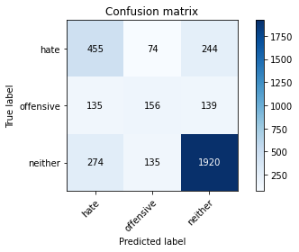

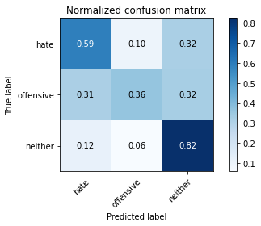

precision recall f1-score support

hate 0.53 0.59 0.56 773

offensive 0.43 0.36 0.39 430

neither 0.83 0.82 0.83 2329

accuracy 0.72 3532

macro avg 0.60 0.59 0.59 3532

weighted avg 0.72 0.72 0.72 3532

average eval_loss: 0.6901362006273647, accuracy: 0.7165911664779162

training 3 epoch...

39.34406661987305 seconds used......

3 training finished! average train loss: 0.3483407296598914

evaluating...

Confusion matrix, without normalization

[[ 309 81 383]

[ 72 152 206]

[ 91 81 2157]]

Normalized confusion matrix

[[0.39974127 0.10478655 0.49547219]

[0.16744186 0.35348837 0.47906977]

[0.03907256 0.03477888 0.92614856]]

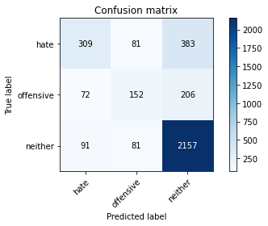

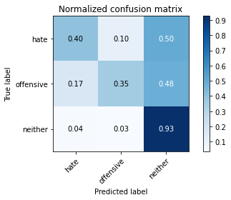

precision recall f1-score support

hate 0.65 0.40 0.50 773

offensive 0.48 0.35 0.41 430

neither 0.79 0.93 0.85 2329

accuracy 0.74 3532

macro avg 0.64 0.56 0.59 3532

weighted avg 0.72 0.74 0.72 3532

average eval_loss: 0.7981791436503836, accuracy: 0.7412231030577576

training 4 epoch...

39.281489849090576 seconds used......

4 training finished! average train loss: 0.17812439790344176

evaluating...

Confusion matrix, without normalization

[[ 335 147 291]

[ 66 224 140]

[ 150 196 1983]]

Normalized confusion matrix

[[0.43337646 0.19016818 0.37645537]

[0.15348837 0.52093023 0.3255814 ]

[0.06440532 0.08415629 0.85143839]]

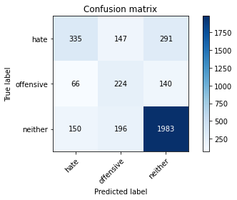

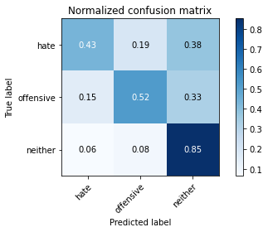

precision recall f1-score support

hate 0.61 0.43 0.51 773

offensive 0.40 0.52 0.45 430

neither 0.82 0.85 0.84 2329

accuracy 0.72 3532

macro avg 0.61 0.60 0.60 3532

weighted avg 0.72 0.72 0.72 3532

average eval_loss: 0.8989986255344025, accuracy: 0.7197055492638732

training 5 epoch...

39.30790185928345 seconds used......

5 training finished! average train loss: 0.06996999751218659

evaluating...

Confusion matrix, without normalization

[[ 343 134 296]

[ 66 210 154]

[ 152 177 2000]]

Normalized confusion matrix

[[0.44372574 0.17335058 0.38292367]

[0.15348837 0.48837209 0.35813953]

[0.06526406 0.07599828 0.85873766]]

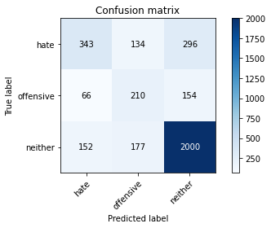

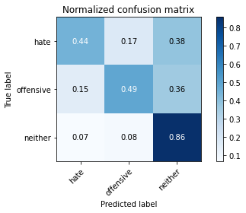

precision recall f1-score support

hate 0.61 0.44 0.51 773

offensive 0.40 0.49 0.44 430

neither 0.82 0.86 0.84 2329

accuracy 0.72 3532

macro avg 0.61 0.60 0.60 3532

weighted avg 0.72 0.72 0.72 3532

average eval_loss: 1.0793801732150847, accuracy: 0.7228199320498301

training 6 epoch...

39.34477376937866 seconds used......

6 training finished! average train loss: 0.029023368607578988

evaluating...

Confusion matrix, without normalization

[[ 419 87 267]

[ 112 182 136]

[ 246 157 1926]]

Normalized confusion matrix

[[0.54204398 0.11254851 0.3454075 ]

[0.26046512 0.42325581 0.31627907]

[0.10562473 0.06741091 0.82696436]]

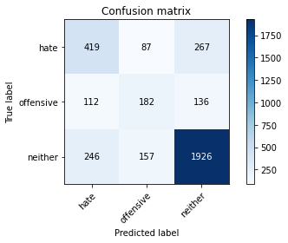

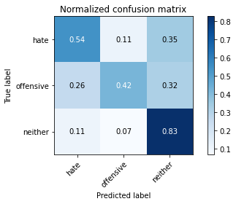

precision recall f1-score support

hate 0.54 0.54 0.54 773

offensive 0.43 0.42 0.43 430

neither 0.83 0.83 0.83 2329

accuracy 0.72 3532

macro avg 0.60 0.60 0.60 3532

weighted avg 0.72 0.72 0.72 3532

average eval_loss: 1.2963172476843925, accuracy: 0.7154586636466591

training 7 epoch...

39.290090560913086 seconds used......

7 training finished! average train loss: 0.01254183572360917

evaluating...

Confusion matrix, without normalization

[[ 337 98 338]

[ 81 196 153]

[ 140 147 2042]]

Normalized confusion matrix

[[0.43596378 0.12677878 0.43725744]

[0.18837209 0.45581395 0.35581395]

[0.06011164 0.06311722 0.87677115]]

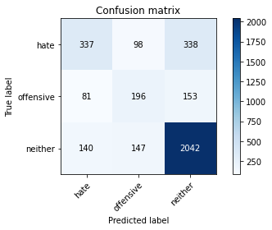

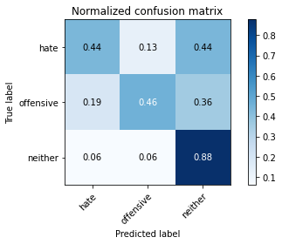

precision recall f1-score support

hate 0.60 0.44 0.51 773

offensive 0.44 0.46 0.45 430

neither 0.81 0.88 0.84 2329

accuracy 0.73 3532

macro avg 0.62 0.59 0.60 3532

weighted avg 0.72 0.73 0.72 3532

average eval_loss: 1.4356908356655116, accuracy: 0.7290486976217441

training 8 epoch...

39.27631878852844 seconds used......

8 training finished! average train loss: 0.010911107501874176

evaluating...

Confusion matrix, without normalization

[[ 301 159 313]

[ 53 239 138]

[ 117 229 1983]]

Normalized confusion matrix

[[0.38939198 0.20569211 0.40491591]

[0.12325581 0.55581395 0.32093023]

[0.05023615 0.09832546 0.85143839]]

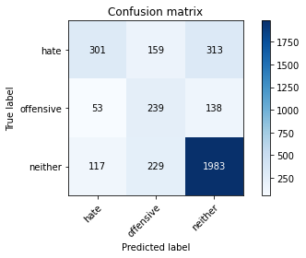

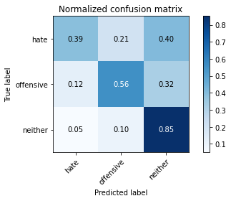

precision recall f1-score support

hate 0.64 0.39 0.48 773

offensive 0.38 0.56 0.45 430

neither 0.81 0.85 0.83 2329

accuracy 0.71 3532

macro avg 0.61 0.60 0.59 3532

weighted avg 0.72 0.71 0.71 3532

average eval_loss: 1.5304619711166048, accuracy: 0.714326160815402

training 9 epoch...

39.31382155418396 seconds used......

9 training finished! average train loss: 0.011599155903649442

evaluating...

Confusion matrix, without normalization

[[ 358 106 309]

[ 77 195 158]

[ 174 142 2013]]

Normalized confusion matrix

[[0.46313066 0.13712807 0.39974127]

[0.17906977 0.45348837 0.36744186]

[0.07471018 0.06097037 0.86431945]]

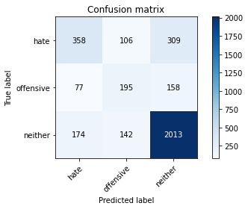

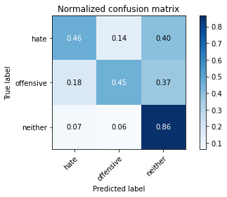

precision recall f1-score support

hate 0.59 0.46 0.52 773

offensive 0.44 0.45 0.45 430

neither 0.81 0.86 0.84 2329

accuracy 0.73 3532

macro avg 0.61 0.59 0.60 3532

weighted avg 0.72 0.73 0.72 3532

average eval_loss: 1.5051744740224828, accuracy: 0.7265005662514157

training 10 epoch...

39.30343508720398 seconds used......

10 training finished! average train loss: 0.010496090980944532

evaluating...

Confusion matrix, without normalization

[[ 376 101 296]

[ 99 189 142]

[ 197 159 1973]]

Normalized confusion matrix

[[0.48641656 0.13065977 0.38292367]

[0.23023256 0.43953488 0.33023256]

[0.08458566 0.06826964 0.8471447 ]]

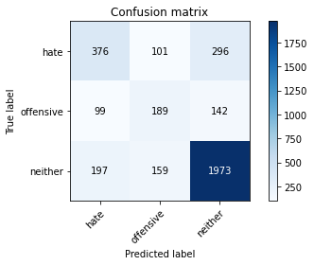

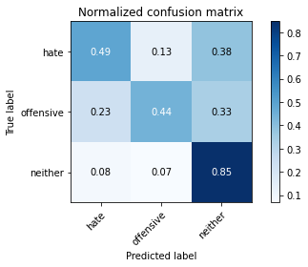

precision recall f1-score support

hate 0.56 0.49 0.52 773

offensive 0.42 0.44 0.43 430

neither 0.82 0.85 0.83 2329

accuracy 0.72 3532

macro avg 0.60 0.59 0.59 3532

weighted avg 0.71 0.72 0.72 3532

average eval_loss: 1.580899113315647, accuracy: 0.7185730464326161

4 run......

training 1 epoch...

39.35798668861389 seconds used......

1 training finished! average train loss: 0.8517026329104276

evaluating...

Confusion matrix, without normalization

[[ 322 123 328]

[ 73 166 191]

[ 167 127 2035]]

Normalized confusion matrix

[[0.41655886 0.15912031 0.42432083]

[0.16976744 0.38604651 0.44418605]

[0.07170459 0.05452984 0.87376556]]

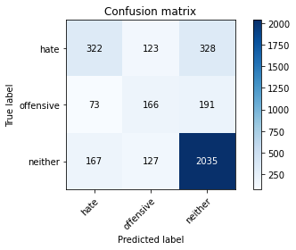

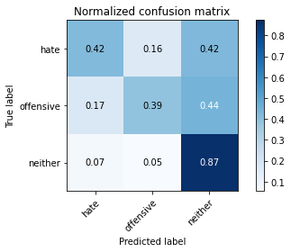

precision recall f1-score support

hate 0.57 0.42 0.48 773

offensive 0.40 0.39 0.39 430

neither 0.80 0.87 0.83 2329

accuracy 0.71 3532

macro avg 0.59 0.56 0.57 3532

weighted avg 0.70 0.71 0.70 3532

average eval_loss: 0.6892471360621479, accuracy: 0.714326160815402

training 2 epoch...

39.310800313949585 seconds used......

2 training finished! average train loss: 0.5881350865976058

evaluating...

Confusion matrix, without normalization

[[ 352 96 325]

[ 86 162 182]

[ 151 116 2062]]

Normalized confusion matrix

[[0.45536869 0.12419146 0.42043984]

[0.2 0.37674419 0.42325581]

[0.06483469 0.04980678 0.88535852]]

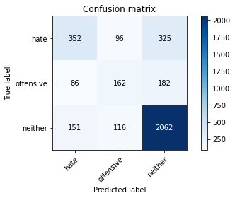

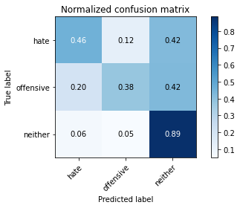

precision recall f1-score support

hate 0.60 0.46 0.52 773

offensive 0.43 0.38 0.40 430

neither 0.80 0.89 0.84 2329

accuracy 0.73 3532

macro avg 0.61 0.57 0.59 3532

weighted avg 0.71 0.73 0.72 3532

average eval_loss: 0.6689851811881793, accuracy: 0.7293318233295584

training 3 epoch...

39.31806564331055 seconds used......

3 training finished! average train loss: 0.3627859148032525

evaluating...

Confusion matrix, without normalization

[[ 309 140 324]

[ 56 193 181]

[ 135 143 2051]]

Normalized confusion matrix

[[0.39974127 0.18111255 0.41914618]

[0.13023256 0.44883721 0.42093023]

[0.05796479 0.06139974 0.88063547]]

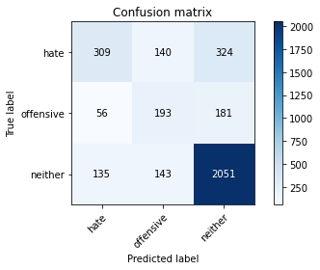

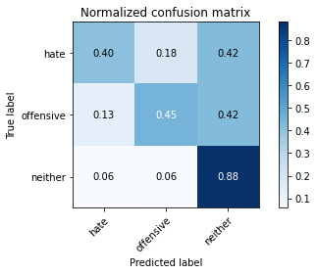

precision recall f1-score support

hate 0.62 0.40 0.49 773

offensive 0.41 0.45 0.43 430

neither 0.80 0.88 0.84 2329

accuracy 0.72 3532

macro avg 0.61 0.58 0.58 3532

weighted avg 0.71 0.72 0.71 3532

average eval_loss: 0.800790272105885, accuracy: 0.7228199320498301

training 4 epoch...

39.34529781341553 seconds used......

4 training finished! average train loss: 0.17182550300410723

evaluating...

Confusion matrix, without normalization

[[ 437 87 249]

[ 115 174 141]

[ 257 158 1914]]

Normalized confusion matrix

[[0.56532988 0.11254851 0.3221216 ]

[0.26744186 0.40465116 0.32790698]

[0.11034779 0.06784027 0.82181194]]

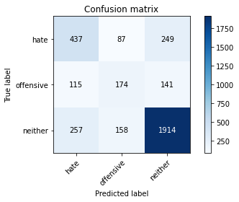

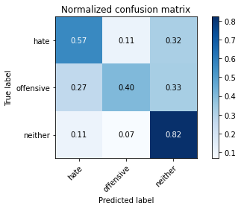

precision recall f1-score support

hate 0.54 0.57 0.55 773

offensive 0.42 0.40 0.41 430

neither 0.83 0.82 0.83 2329

accuracy 0.71 3532

macro avg 0.60 0.60 0.60 3532

weighted avg 0.72 0.71 0.72 3532

average eval_loss: 0.9374338780756051, accuracy: 0.7148924122310306

training 5 epoch...

39.2812135219574 seconds used......

5 training finished! average train loss: 0.06595944376154379

evaluating...

Confusion matrix, without normalization

[[ 425 74 274]

[ 122 162 146]

[ 258 126 1945]]

Normalized confusion matrix

[[0.54980595 0.09573092 0.35446313]

[0.28372093 0.37674419 0.33953488]

[0.11077716 0.05410047 0.83512237]]

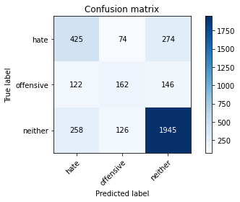

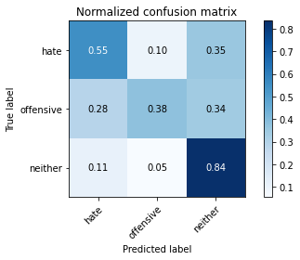

precision recall f1-score support

hate 0.53 0.55 0.54 773

offensive 0.45 0.38 0.41 430

neither 0.82 0.84 0.83 2329

accuracy 0.72 3532

macro avg 0.60 0.59 0.59 3532

weighted avg 0.71 0.72 0.71 3532

average eval_loss: 1.1346386089752623, accuracy: 0.7168742921857305

training 6 epoch...

39.274388551712036 seconds used......

6 training finished! average train loss: 0.03011059660133333

evaluating...

Confusion matrix, without normalization

[[ 302 82 389]

[ 67 140 223]

[ 117 66 2146]]

Normalized confusion matrix

[[0.39068564 0.10608021 0.50323415]

[0.15581395 0.3255814 0.51860465]

[0.05023615 0.02833834 0.9214255 ]]

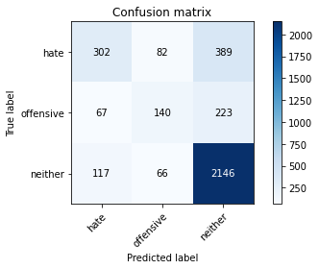

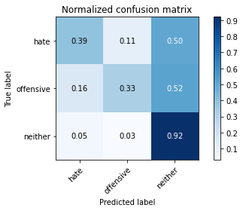

precision recall f1-score support

hate 0.62 0.39 0.48 773

offensive 0.49 0.33 0.39 430

neither 0.78 0.92 0.84 2329

accuracy 0.73 3532

macro avg 0.63 0.55 0.57 3532

weighted avg 0.71 0.73 0.71 3532

average eval_loss: 1.3180354223665545, accuracy: 0.7327293318233296

training 7 epoch...

39.289769887924194 seconds used......

7 training finished! average train loss: 0.028141755554675657

evaluating...

Confusion matrix, without normalization

[[ 270 107 396]

[ 59 172 199]

[ 102 100 2127]]

Normalized confusion matrix

[[0.34928849 0.13842173 0.51228978]

[0.1372093 0.4 0.4627907 ]

[0.04379562 0.04293688 0.9132675 ]]

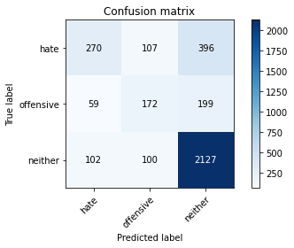

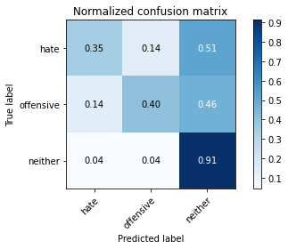

precision recall f1-score support

hate 0.63 0.35 0.45 773

offensive 0.45 0.40 0.43 430

neither 0.78 0.91 0.84 2329

accuracy 0.73 3532

macro avg 0.62 0.55 0.57 3532

weighted avg 0.71 0.73 0.71 3532

average eval_loss: 1.3529402278574174, accuracy: 0.7273499433748585

training 8 epoch...

39.3505117893219 seconds used......

8 training finished! average train loss: 0.015485800743254927

evaluating...

Confusion matrix, without normalization

[[ 386 111 276]

[ 83 176 171]

[ 220 136 1973]]

Normalized confusion matrix

[[0.49935317 0.14359638 0.35705045]

[0.19302326 0.40930233 0.39767442]

[0.09446114 0.05839416 0.8471447 ]]

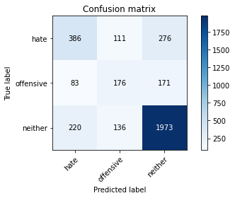

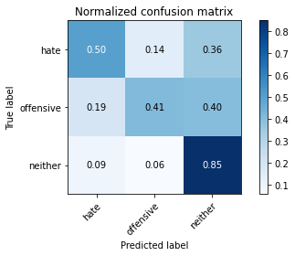

precision recall f1-score support

hate 0.56 0.50 0.53 773

offensive 0.42 0.41 0.41 430

neither 0.82 0.85 0.83 2329

accuracy 0.72 3532

macro avg 0.60 0.59 0.59 3532

weighted avg 0.71 0.72 0.71 3532

average eval_loss: 1.34869217384333, accuracy: 0.7177236693091733

training 9 epoch...

39.3222770690918 seconds used......

9 training finished! average train loss: 0.010221195725019384

evaluating...

Confusion matrix, without normalization

[[ 352 114 307]

[ 74 179 177]

[ 171 143 2015]]

Normalized confusion matrix

[[0.45536869 0.14747736 0.39715395]

[0.17209302 0.41627907 0.41162791]

[0.07342207 0.06139974 0.86517819]]

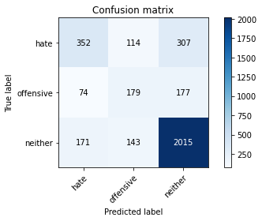

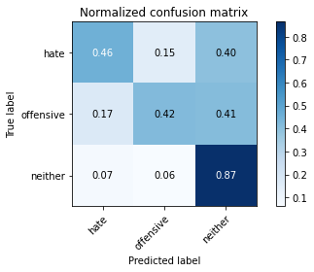

precision recall f1-score support

hate 0.59 0.46 0.51 773

offensive 0.41 0.42 0.41 430

neither 0.81 0.87 0.83 2329

accuracy 0.72 3532

macro avg 0.60 0.58 0.59 3532

weighted avg 0.71 0.72 0.71 3532

average eval_loss: 1.4374642664261457, accuracy: 0.7208380520951302

training 10 epoch...

39.29179883003235 seconds used......

10 training finished! average train loss: 0.012360928947308952

evaluating...

Confusion matrix, without normalization

[[ 322 147 304]

[ 66 212 152]

[ 163 220 1946]]

Normalized confusion matrix

[[0.41655886 0.19016818 0.39327296]

[0.15348837 0.49302326 0.35348837]

[0.06998712 0.09446114 0.83555174]]

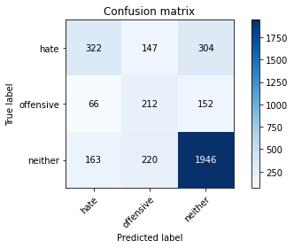

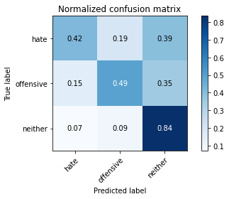

precision recall f1-score support

hate 0.58 0.42 0.49 773

offensive 0.37 0.49 0.42 430

neither 0.81 0.84 0.82 2329

accuracy 0.70 3532

macro avg 0.59 0.58 0.58 3532

weighted avg 0.71 0.70 0.70 3532

average eval_loss: 1.5630161064324406, accuracy: 0.7021517553793885

5 run......

training 1 epoch...

39.26427912712097 seconds used......

1 training finished! average train loss: 0.8571945784244945

evaluating...

Confusion matrix, without normalization

[[ 303 49 421]

[ 85 96 249]

[ 125 40 2164]]

Normalized confusion matrix

[[0.3919793 0.06338939 0.54463131]

[0.19767442 0.22325581 0.57906977]

[0.0536711 0.01717475 0.92915414]]

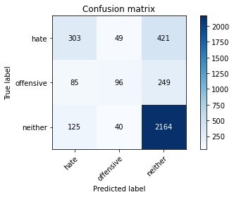

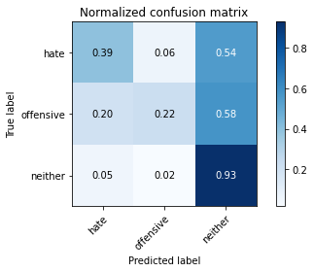

precision recall f1-score support

hate 0.59 0.39 0.47 773

offensive 0.52 0.22 0.31 430

neither 0.76 0.93 0.84 2329

accuracy 0.73 3532

macro avg 0.62 0.51 0.54 3532

weighted avg 0.70 0.73 0.69 3532

average eval_loss: 0.6946921506843998, accuracy: 0.7256511891279728

training 2 epoch...

39.302711725234985 seconds used......

2 training finished! average train loss: 0.6010549467674551

evaluating...

Confusion matrix, without normalization

[[ 362 147 264]

[ 82 196 152]

[ 189 221 1919]]

Normalized confusion matrix

[[0.4683053 0.19016818 0.34152652]

[0.19069767 0.45581395 0.35348837]

[0.08115071 0.09489051 0.82395878]]

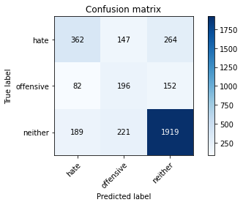

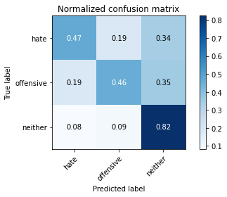

precision recall f1-score support

hate 0.57 0.47 0.51 773

offensive 0.35 0.46 0.39 430

neither 0.82 0.82 0.82 2329

accuracy 0.70 3532

macro avg 0.58 0.58 0.58 3532

weighted avg 0.71 0.70 0.70 3532

average eval_loss: 0.71834505513563, accuracy: 0.7013023782559457

training 3 epoch...

39.28414607048035 seconds used......

3 training finished! average train loss: 0.38748772506089135

evaluating...

Confusion matrix, without normalization

[[ 288 155 330]

[ 54 194 182]

[ 112 182 2035]]

Normalized confusion matrix

[[0.37257439 0.20051746 0.42690815]

[0.1255814 0.45116279 0.42325581]

[0.04808931 0.07814513 0.87376556]]

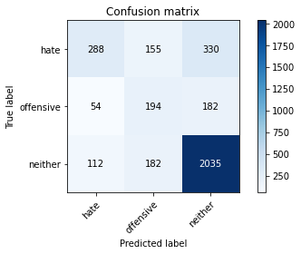

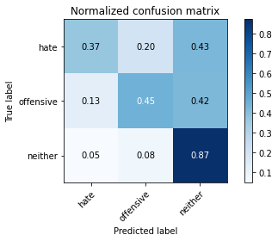

precision recall f1-score support

hate 0.63 0.37 0.47 773

offensive 0.37 0.45 0.40 430

neither 0.80 0.87 0.83 2329

accuracy 0.71 3532

macro avg 0.60 0.57 0.57 3532

weighted avg 0.71 0.71 0.70 3532

average eval_loss: 0.7587394896200148, accuracy: 0.7126274065685164

training 4 epoch...

39.247467041015625 seconds used......

4 training finished! average train loss: 0.18664307625376605

evaluating...

Confusion matrix, without normalization

[[ 379 171 223]

[ 68 231 131]

[ 221 299 1809]]

Normalized confusion matrix

[[0.49029754 0.22121604 0.28848642]

[0.15813953 0.5372093 0.30465116]

[0.09489051 0.12838128 0.77672821]]

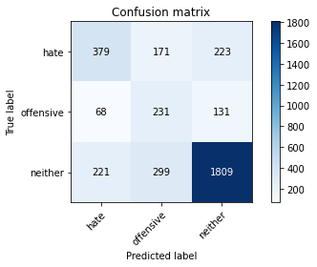

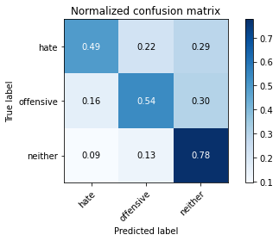

precision recall f1-score support

hate 0.57 0.49 0.53 773

offensive 0.33 0.54 0.41 430

neither 0.84 0.78 0.81 2329

accuracy 0.68 3532

macro avg 0.58 0.60 0.58 3532

weighted avg 0.72 0.68 0.70 3532

average eval_loss: 0.9896374408808132, accuracy: 0.684881087202718

training 5 epoch...

39.309484243392944 seconds used......

5 training finished! average train loss: 0.0786418342604277

evaluating...

Confusion matrix, without normalization

[[ 362 127 284]

[ 77 189 164]

[ 186 175 1968]]

Normalized confusion matrix

[[0.4683053 0.16429495 0.36739974]

[0.17906977 0.43953488 0.38139535]

[0.0798626 0.07513954 0.84499785]]

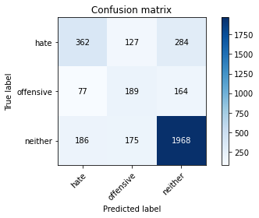

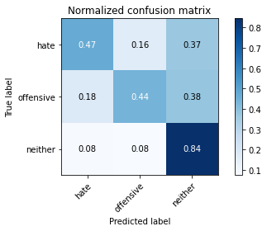

precision recall f1-score support

hate 0.58 0.47 0.52 773

offensive 0.38 0.44 0.41 430

neither 0.81 0.84 0.83 2329

accuracy 0.71 3532

macro avg 0.59 0.58 0.59 3532

weighted avg 0.71 0.71 0.71 3532

average eval_loss: 1.098411622862358, accuracy: 0.7131936579841449

training 6 epoch...

39.29276180267334 seconds used......

6 training finished! average train loss: 0.03111246904423012

evaluating...

Confusion matrix, without normalization

[[ 336 87 350]

[ 78 156 196]

[ 131 111 2087]]

Normalized confusion matrix

[[0.43467012 0.11254851 0.45278137]

[0.18139535 0.3627907 0.45581395]

[0.05624732 0.04765994 0.89609274]]

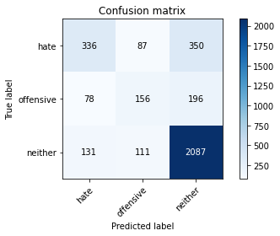

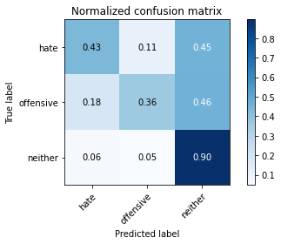

precision recall f1-score support

hate 0.62 0.43 0.51 773

offensive 0.44 0.36 0.40 430

neither 0.79 0.90 0.84 2329

accuracy 0.73 3532

macro avg 0.62 0.56 0.58 3532

weighted avg 0.71 0.73 0.71 3532

average eval_loss: 1.2751463058136276, accuracy: 0.7301812004530012

training 7 epoch...

39.26421117782593 seconds used......

7 training finished! average train loss: 0.021146148367271942

evaluating...

Confusion matrix, without normalization

[[ 385 122 266]

[ 79 183 168]

[ 220 179 1930]]

Normalized confusion matrix

[[0.49805951 0.15782665 0.34411384]

[0.18372093 0.4255814 0.39069767]

[0.09446114 0.07685702 0.82868184]]

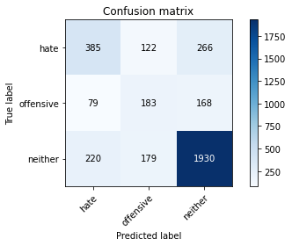

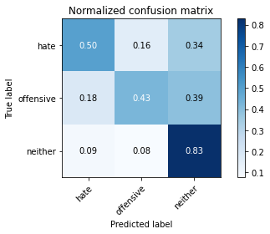

precision recall f1-score support

hate 0.56 0.50 0.53 773

offensive 0.38 0.43 0.40 430

neither 0.82 0.83 0.82 2329

accuracy 0.71 3532

macro avg 0.59 0.58 0.58 3532

weighted avg 0.71 0.71 0.71 3532

average eval_loss: 1.3755786526253668, accuracy: 0.7072480181200453

training 8 epoch...

39.30894422531128 seconds used......

8 training finished! average train loss: 0.019891289536863626

evaluating...

Confusion matrix, without normalization

[[ 371 120 282]

[ 92 189 149]

[ 200 193 1936]]

Normalized confusion matrix

[[0.47994825 0.15523933 0.36481242]

[0.21395349 0.43953488 0.34651163]

[0.08587377 0.08286818 0.83125805]]

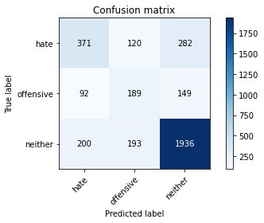

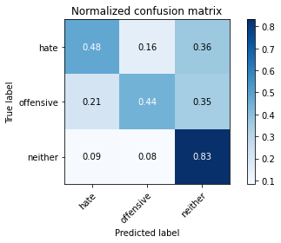

precision recall f1-score support

hate 0.56 0.48 0.52 773

offensive 0.38 0.44 0.41 430

neither 0.82 0.83 0.82 2329

accuracy 0.71 3532

macro avg 0.58 0.58 0.58 3532

weighted avg 0.71 0.71 0.71 3532

average eval_loss: 1.4301960780206373, accuracy: 0.7066817667044167

training 9 epoch...

39.262470722198486 seconds used......

9 training finished! average train loss: 0.014065944686635362

evaluating...

Confusion matrix, without normalization

[[ 453 61 259]

[ 144 127 159]

[ 288 95 1946]]

Normalized confusion matrix

[[0.58602846 0.07891332 0.33505821]

[0.33488372 0.29534884 0.36976744]

[0.12365822 0.04079004 0.83555174]]

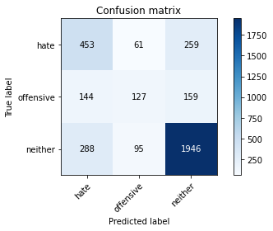

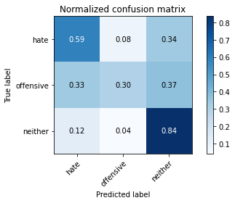

precision recall f1-score support

hate 0.51 0.59 0.55 773

offensive 0.45 0.30 0.36 430

neither 0.82 0.84 0.83 2329

accuracy 0.72 3532

macro avg 0.59 0.57 0.58 3532

weighted avg 0.71 0.72 0.71 3532

average eval_loss: 1.4978233303895778, accuracy: 0.7151755379388448

training 10 epoch...

39.27212905883789 seconds used......

10 training finished! average train loss: 0.01076070027177491

evaluating...

Confusion matrix, without normalization

[[ 455 105 213]

[ 118 176 136]

[ 326 165 1838]]

Normalized confusion matrix

[[0.58861578 0.13583441 0.27554981]

[0.2744186 0.40930233 0.31627907]

[0.13997424 0.07084586 0.78917991]]

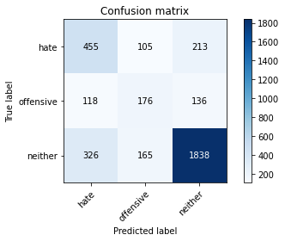

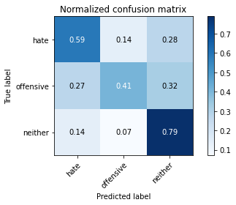

precision recall f1-score support

hate 0.51 0.59 0.54 773

offensive 0.39 0.41 0.40 430

neither 0.84 0.79 0.81 2329

accuracy 0.70 3532

macro avg 0.58 0.60 0.59 3532

weighted avg 0.71 0.70 0.70 3532

average eval_loss: 1.6156527794013589, accuracy: 0.6990373725934315